Marcus B. Ford Park-Playground
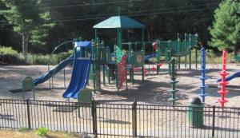
Birch Street
Pembroke, Ma 02359

Pembroke Community Center
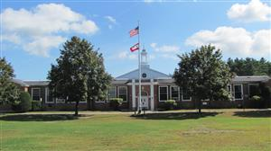
128 Center Street
Pembroke, MA 02359
Phone: (781) 293-3249

Town Green
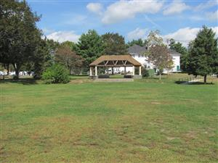
128 Center Street
Pembroke, MA 02359

Indoor Baseball/Softball Facility
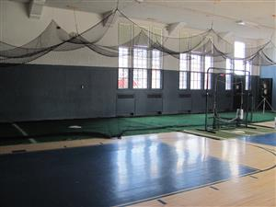
128 Center Street (Community Center Gymnasium)
Pembroke, MA 02359

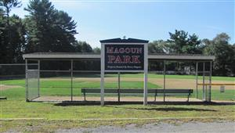
Magoun Park
Intersection of Routes 53 and 139
Pembroke, Ma 02359
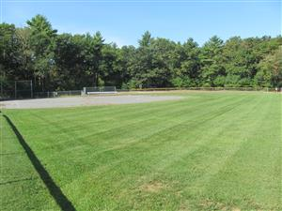

Howard Bezanson Fields
Community Center 128 Center Street
Pembroke, MA 02359

Libby Short Basketball Court #1 (Inside Court)
Community Center Outside Courts
Pembroke, MA 02359
Phone: (781) 293-3249

Libby Short Basketball Court # 2 (Public)

Community Center Curt
Pembroke, MA 02359
Phone: (781) 293-3249

Mattakeesett Street Complex - Girls' Softball field "2"
415 Mattakeesett Street, Pembroke. Girls' fields are to the far right of the complex-closest to the DPW yard
Pembroke, MA 02359
Mattakeesett Street Complex- Girls' Softball field "1"
415 Mattakeesett Street, Pembroke. Girls' fields are to the far right of the complex-closest to the playground
Pembroke, MA 02359

